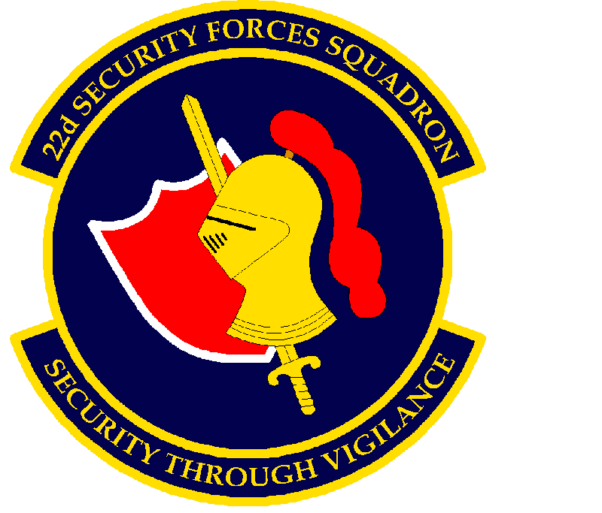
PROCEDURES FOR REQUESTING LARGE GROUP AND SPECIAL EVENTS

Non-base affiliated (non-military affiliated) visitors attending one-time events on base (i.e. wedding, Dole Center function, retirement ceremonies, etc.) must be on a pre-authenticated guest list for any function or event requiring sponsorship of 6 or more adults and or any person over the age of 16 years old with a driver’s license or state issued photo identification. The McConnell AFB 22 SFS Visitor & Area Access Control Offices, 22 SFS/S5P is the authenticating office for all special event guest lists on the installation. Guests need to be advised by the sponsor that all information needed to process passes is mandatory and they are giving the information voluntarily, along with approval for background checks. Visitors who decline to provide required information will not be allowed base access. Guest lists must be received not less than 5 business days prior via encrypted email marked CUI to 22sfs.s5p@us.af.mil. Sponsoring non-U.S. nationals on this request is prohibited and must be sponsored at the Visitor Center. The sponsor will be contacted confirming the event and any guest that has not met base access criteria will be denied access.

The list will be computer generated, listing the name of the event, location of the event (please include specific building numbers), the earliest time guests will be arriving at the gate and the latest time they will be leaving the installation. This request cannot be used for multiple-day events. As the Point of Contact the sponsor’s name and contact number (cellular number is preferred). On the formatted letter, tab through the chart provided, listing all personnel attending the event in alphabetical order, last name, first name, middle initial, date of birth, current REAL ID, drivers’ license, state ID or acceptable alternatives, state of issue and social security number for each individual to include associated services. This includes, but is not limited to caterers, musician’s florists, and vendors.

*** NOTE ***
Once submitted, changes to the provided list will not be authorized unless coordinated and approved by the Chief, Visitor and Area Control section. Additional guests may be sponsored at the Visitor Center on the day of the event. All privately owned vehicles entering McConnell AFB are subject to search prior to entry

Anyone wishing to drive on McConnell AFB must be in possession of a current driver’s license. Drivers will ensure that all passengers wear seatbelts and observe all traffic regulations. Driver’s use of cell phones while driving is prohibited for other than hands free methods. Possession or use of weapons, fireworks or explosives of any kind are unauthorized on the installation.

The sponsor of the event is wholly responsible for the conduct and movement of their guests while on the installation. Further, the POC must be available to be contacted at the event in case of an emergency or disorder.
14 January 2026

MEMORANDUM FOR 22 SFS/S-5P

FROM:

SUBJECT:

1. On <DATE>, the <UNIT> will be sponsoring <EVENT>. The guests will begin arriving at the EAST Gate of McConnell AFB at <TIME> hrs and are shown on the listing and will depart the installation no later than <TIME> hrs.

2. I have included a list of names, social security numbers, dates of birth and driver’s license/State ID numbers and state of issue for all non-DoW affiliated personnel. If you have any questions concerning this event please contact <NAME> at <PHONE>.
Expected Visitors

Last | First/Middle Initial | Date of Birth | DL, Permit or State Id # | State of Issue | Social Security Number | SFS Office use

